TMT/Durgapur/S0691/2026 04.03.2026

To,
Rajib Ghosh
Edifice Engineering Enterprise Private Limited Durgapur - 713203, WB
Click to call: +91-9800004297,+91-343-2576000
E-mail: rajib.ghosh@edificeengineering.co.in , rajib.ghosh@alumnos.upm.es

Dear sir,

Sub: - SUPPLY OF ROLL FORMING MACHINE – WITH CABLE TRAY ROLL FORMING MACHINE.

Thank you very much for your enquiry regarding your requirement of roll forming machine mainly for cable tray Section as per your design. We are glad to inform you that we would be in a position to supply you the required equipment. Given below are the required specifications and description of the machine and our terms and conditions.

Prices for 400 mm width machine

The cost of Roll forming machine with cable tray section tooling along with de coiler, Entry guide, punching press and tooling, main roll forming machine, side guides, post cutting press, with dies, delivery run out table along with drive system with sheet leveler cum feeder also with panel with PLC is Rs 36,00,000/- (Rupees Thirty Six Lakhs only)

LIST OT EQUIPMENT

- DE COILER 4 MT CAPACITY
- PUNCHING PRESS WITH PUNCHING TOOLING
- SHEET LEVELER CUM FEEDER
- ROLL FORMING MACHINE WITH 12 PASSES
- EN 31 C/CABLE TRAY PROFILE TOOLING
- 15 HP DRIVE WITH 1 NUMBER RUDUCTION GEAR BOXE.
- COMPLETE ELECTRICALS ALONG WITH AUTOMATION – PLC
- ENTRY SHEAR
- Power pack with 15 HP

Technical specifications:

Maximum sheet width that can be formed : 400 MM

Maximum sheet thickness in MS that can be formed : 2.5 MM

Minimum sheet thickness in MS that can be formed : 0.8 MM

Roll shaft diameter : dia 90 MM

The vertical distance between shafts : 330 MM

The horizontal distance between shafts : 550 MM

Number of forming stations : 15 Nos

Drive (AC) : 30 HP

Speed of the machine : 8-10 meters/max

Description of the equipment

Roll Forming Machine

Main Base

The main base is MS fabricated structure and adequately ribbed to minimize the distortion. It is accurately machined on top and bottom surfaces the threaded holes are made on the bed for positioning the stands.

Entry Guide

The entry side of the machine will be equipped with guide table and the guide wheels bar which will be responsible for centering the leading ends of the strip into the first pass.

Mill stands

The stands are mounted on the bed of the machine the line alignment can be easily done due to guide ways arranged on the bed of the machine. Each forming head consists of a fixed housing and sliding type out board housing. The mill stands will be arranged to locate shafts mounted on anti-friction bearings. For the top shafts the bearings are housed in the cartridge type bearing blocks. The bottom shaft bearings are located in the bored machined in the housings. The bottom arbors are fixed in position whereas the top arbors along with cartridge blocks could be raised or lowered in vertical guides machined in housings.

Roll shafts

The roll shafts will be manufactured from quality steel and will be keyed to locate tooling.

Drive

The drive to the roll former will be by means of a gear box system. The main drive will be provided by means of 30 HP motor. The speed of the roll former is fixed.

Delivery runout table

The delivery runout table is with four meters length.

Cutoff unit

The cutoff unit with hydraulic press along with cutting die set will be placed in the machine delivery side.

GENERAL TERMS & CONDITIONS:

- Price quoted per unit ex-work. Hyderabad.
- Following charges are additional to your account.
- Freight Charge : As actual to be borne by you.
- Sales Tax : 18% Extra as applicable
- Packing charge : As actual to be borne by you.
- Insurance : As actual to be borne by you.
- Payment : 50% advance along with order 25% after one month balance before delivery but after inspection at our works.
- Delivery : With 50% advance 3 months from date of advance received
- Validity : 3 month from the date of submission.
- Inspection : Inspection at our works prior to dispatch.
- Warranty : The machine is warranted for a period of 12 months from the date of dispatch against any manufacturing defects/ faulty material or bad workmanship of any part or component but not against any kind of abnormal or improper use of machine. Defective part or component will be replaced or repaired free of cost. Electrical components are outside the scope of this warranty.
- Commissioning : Erection & commissioning done by you, but required technical support & guidance provide by us at additional cost.

NOTE:
- Oil is not in scope of our supply.
- Raw material for trial is to be arranged by you at your cost.

We are sure you will find our offer in line with your requirements. Should you require any further clarification please contact Sivaram Krishna 9246221106.

Thanking you and assuring you of our best services.

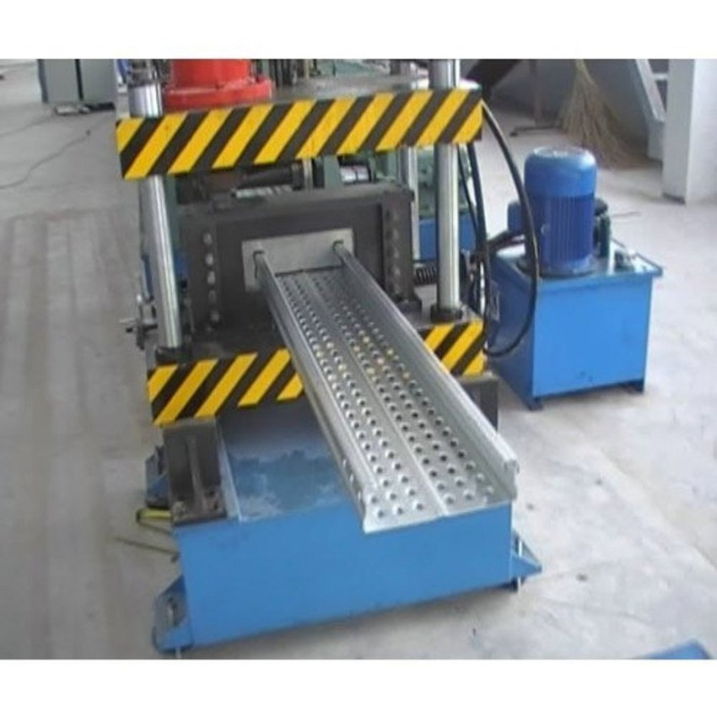

For TECHNO MACHINE TOOLS

( T. SIVARAMAKRISHNA)

